Control Engineering

Handout – Online Laboratory 10

Name: *Colda Andreea Ariana*

Group: *30332*

For the process described by



1. Compute P, PI and PID controllers using ZN open loop method. Compare the performance of the three controllers.

$$H_{P}= 1.3750$$

$$20.42 s + 1.238$$

$$H_{PI}= ---------------$$

$$16.5 s$$

$$41.25 s^2 + 16.5 s + 1.65$$

$$H_{PID}= -------------------------$$

$$10 s$$

*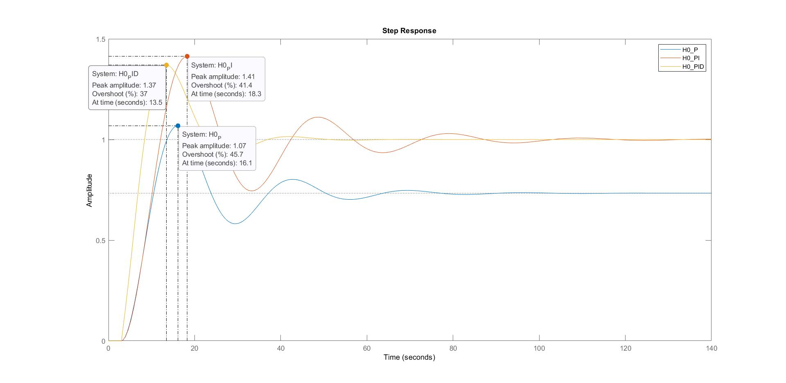*

1. Compute P, PI and PID controllers using ZN closed loop method. Compare the performance.

$$H_{P}= 1.4350$$

$$22.49 s + 1.292$$

$$H_{PI}=---------------$$

$$17.42 s$$

$$47.01 s^2 + 17.99 s + 1.722$$

$$H_{PID}= ---------------------------$$

$$10.45 s$$

*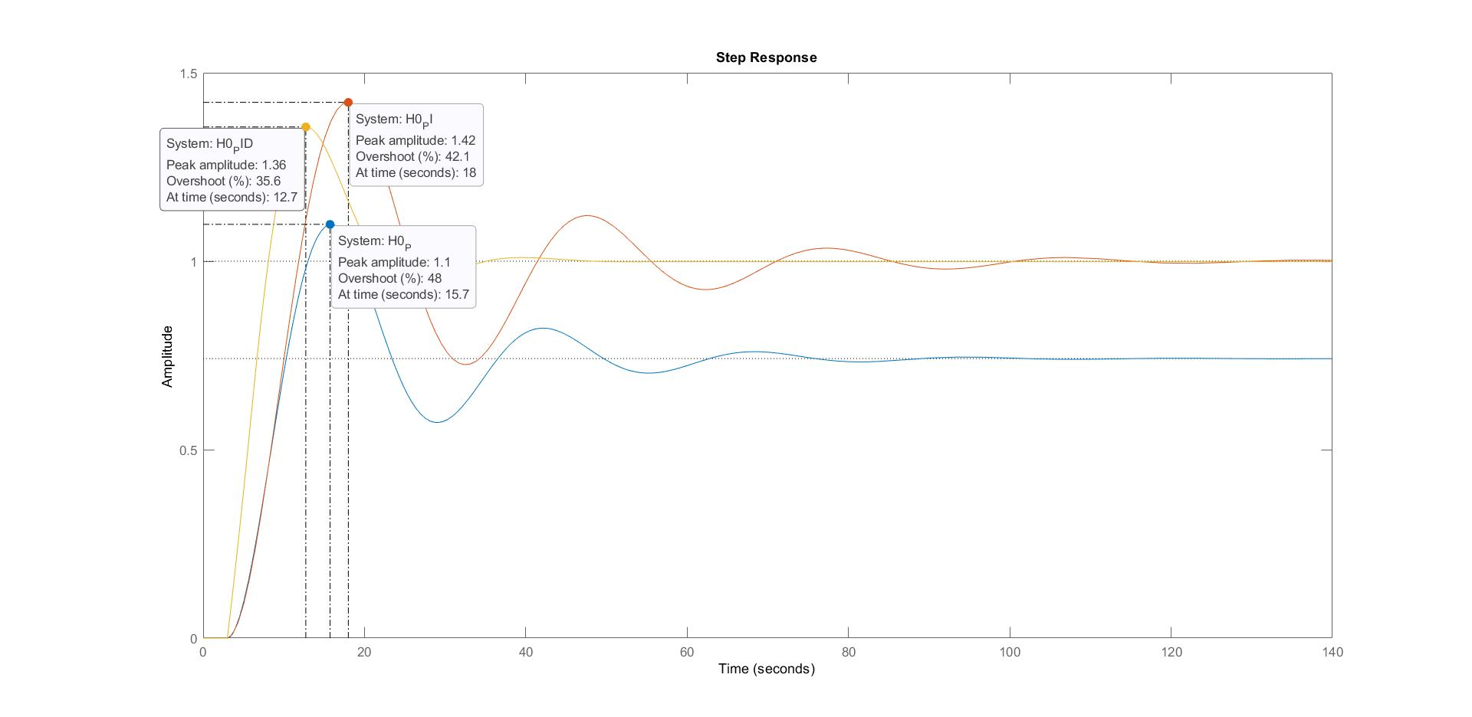*

1. Compare the responses of the closed loop systems with the two PID controllers from a) and b) with the PI controller tuned using frequency domain methods in Lab 7.

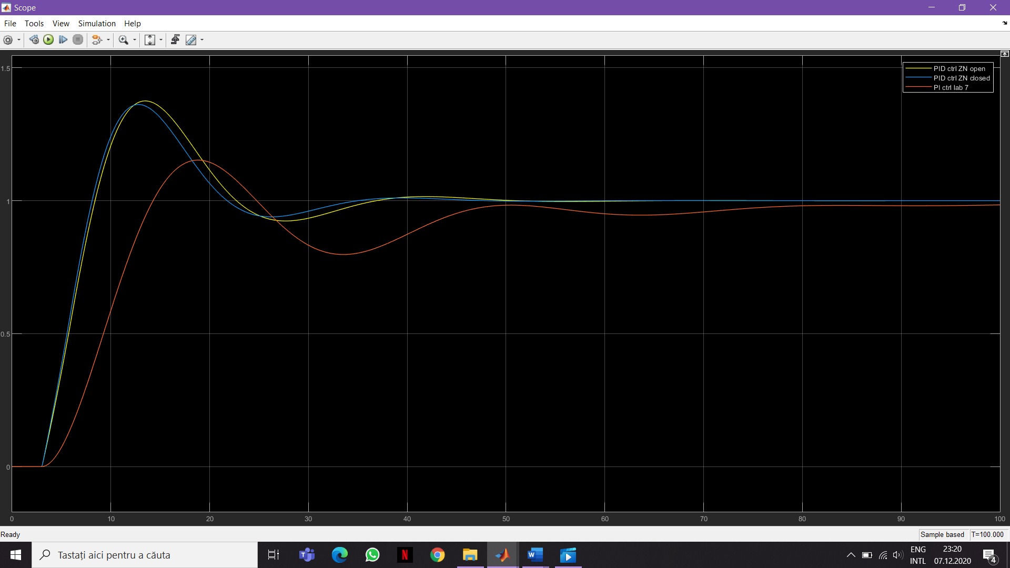

*We can see that the overshoot is almost the same for the PID ctrl and for the PI is smaller. The PID ctrl settles faster than the PI.*

1. Add a step disturbance of amplitude 0.2 at the output of the processes from c). Compare the three controllers from the disturbance rejection perspective.

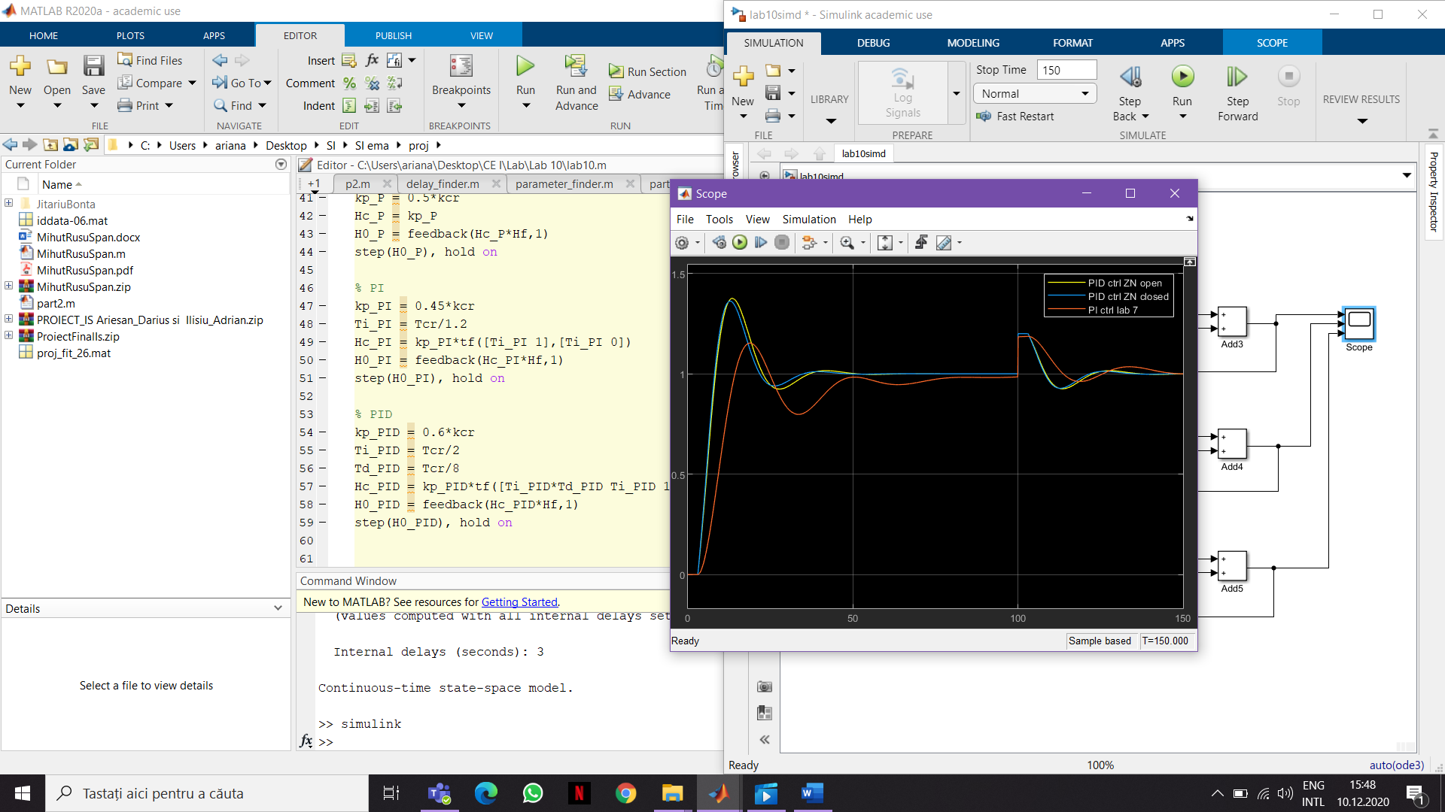

*We can see that the overshoot for the PID ctrl ZN open loop (yellow) is almost 40% and the settling time is about 50 sec. And the steady state error is 0. Then, at 100 sec the output is 1 but we have a disturbance of 0.2 -> it goes to 1.2 and remains at 1.2 for 3 sec (the time delay). It means that the output doesn’t change because it needs 3 sec in order to react to any change. And after 3 sec the output goes to its initial value. And because of the integrator it can reject step disturbances.*

*For the PID ctrl ZN close loop (blue) it is quite similar to the yellow one. The overshoot is a little bit smaller, but the settling time is almost the same. And also the disturbance rejection is almost the same.*

*For the PI ctrl form lab 7, the overshoot is smaller, the settling time is larger.*